Name: Kainaat Rafiq Hussain Makhani
Registration Number: 2012296
Semester and Section: 7A
Lab 09
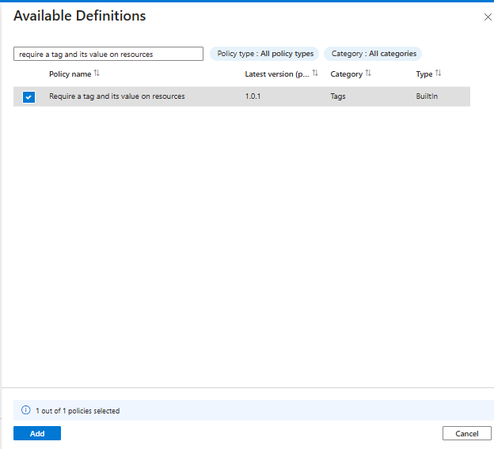

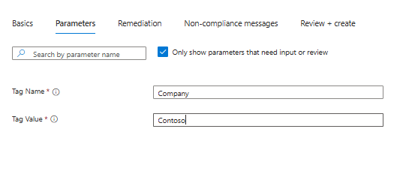

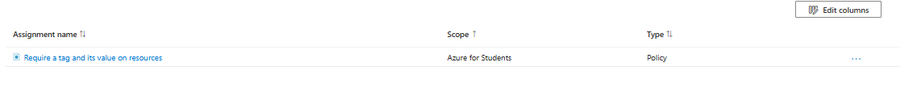

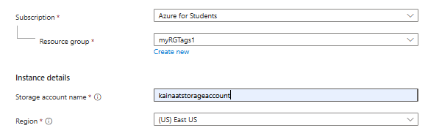

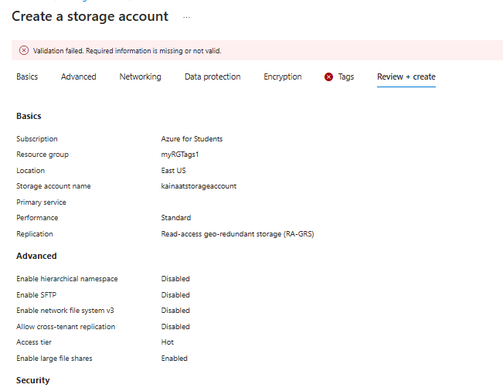

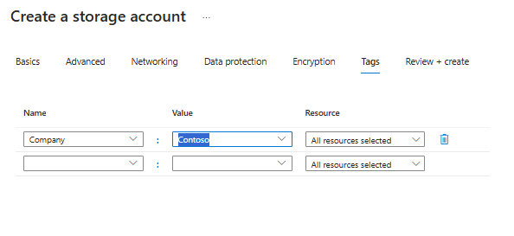

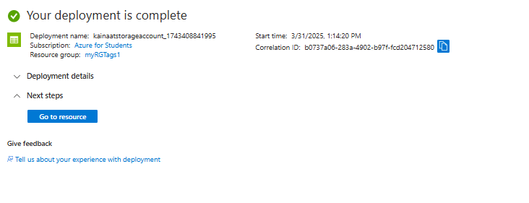

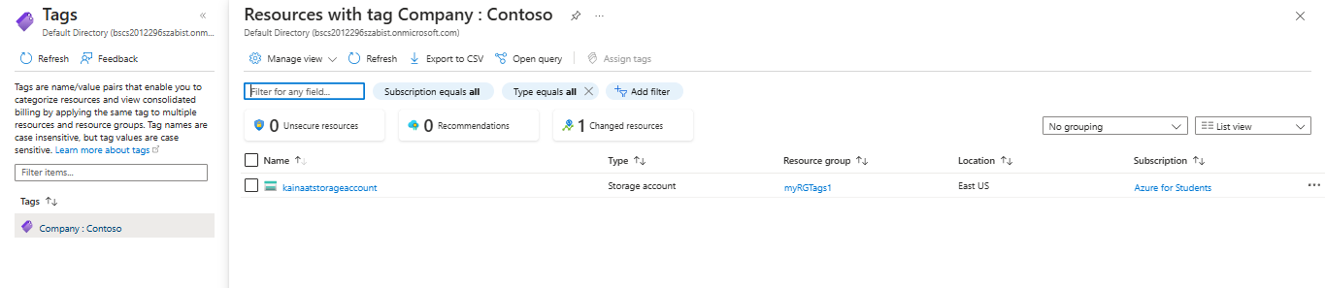

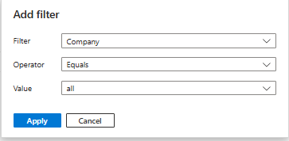

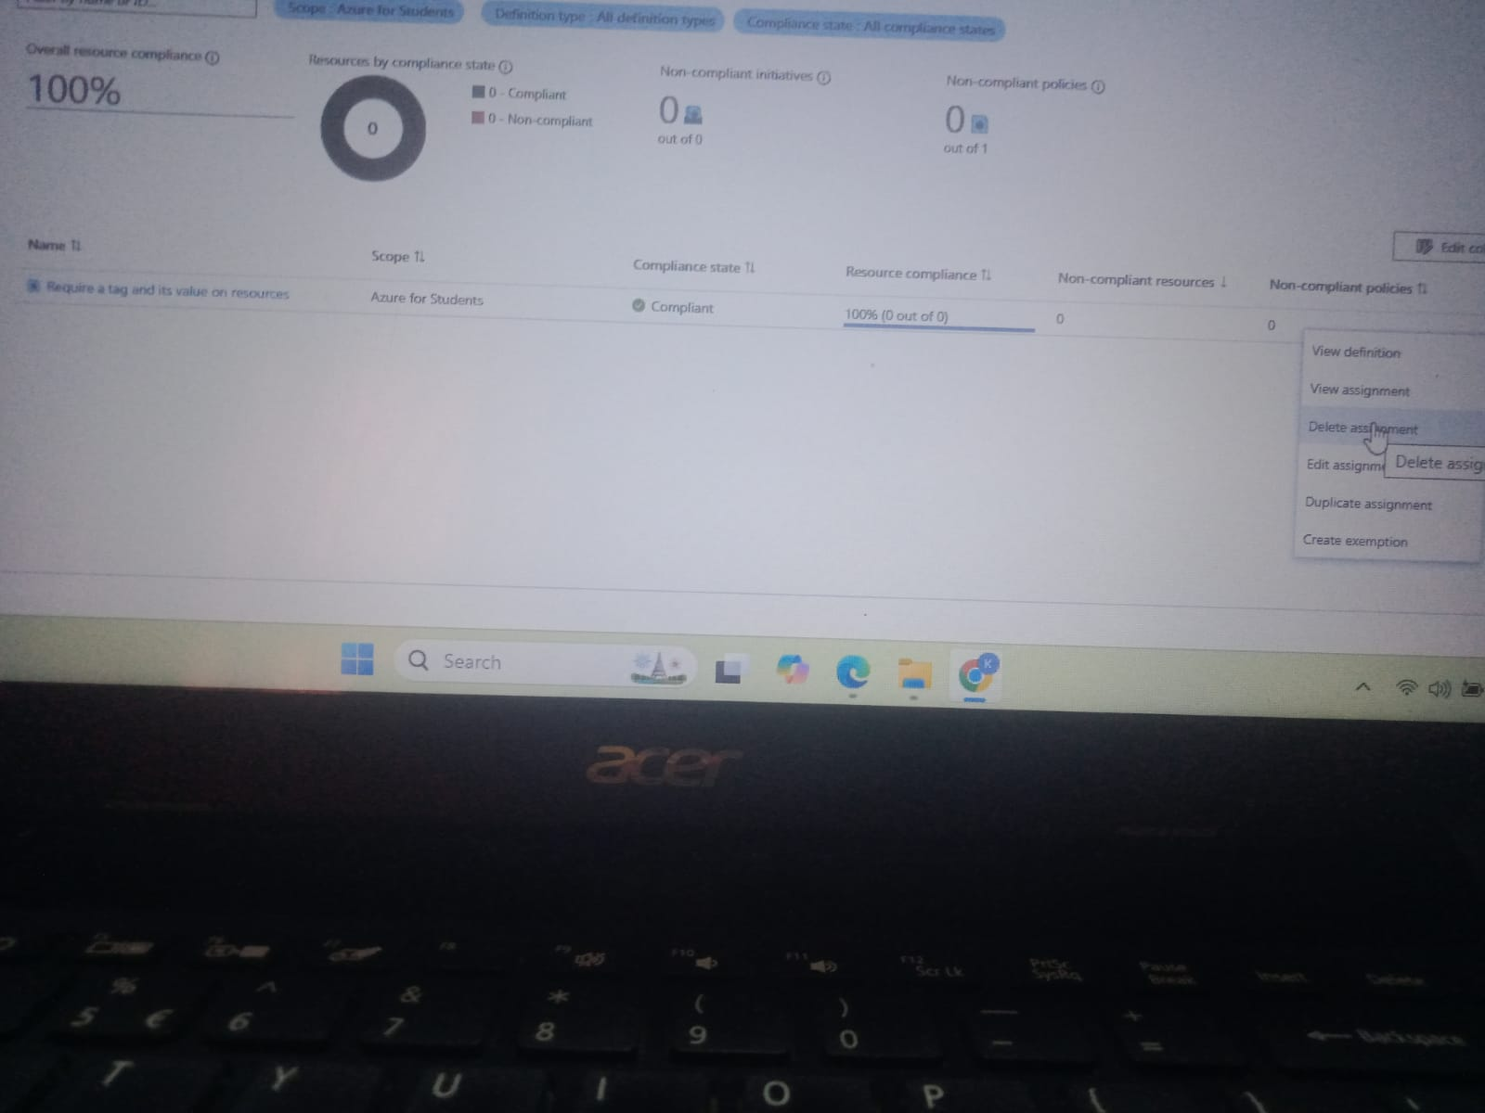

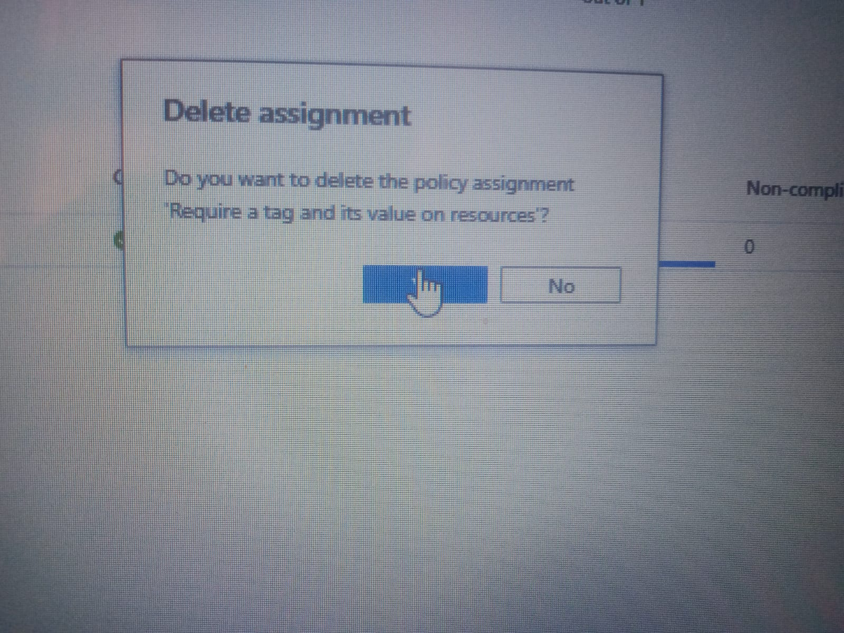

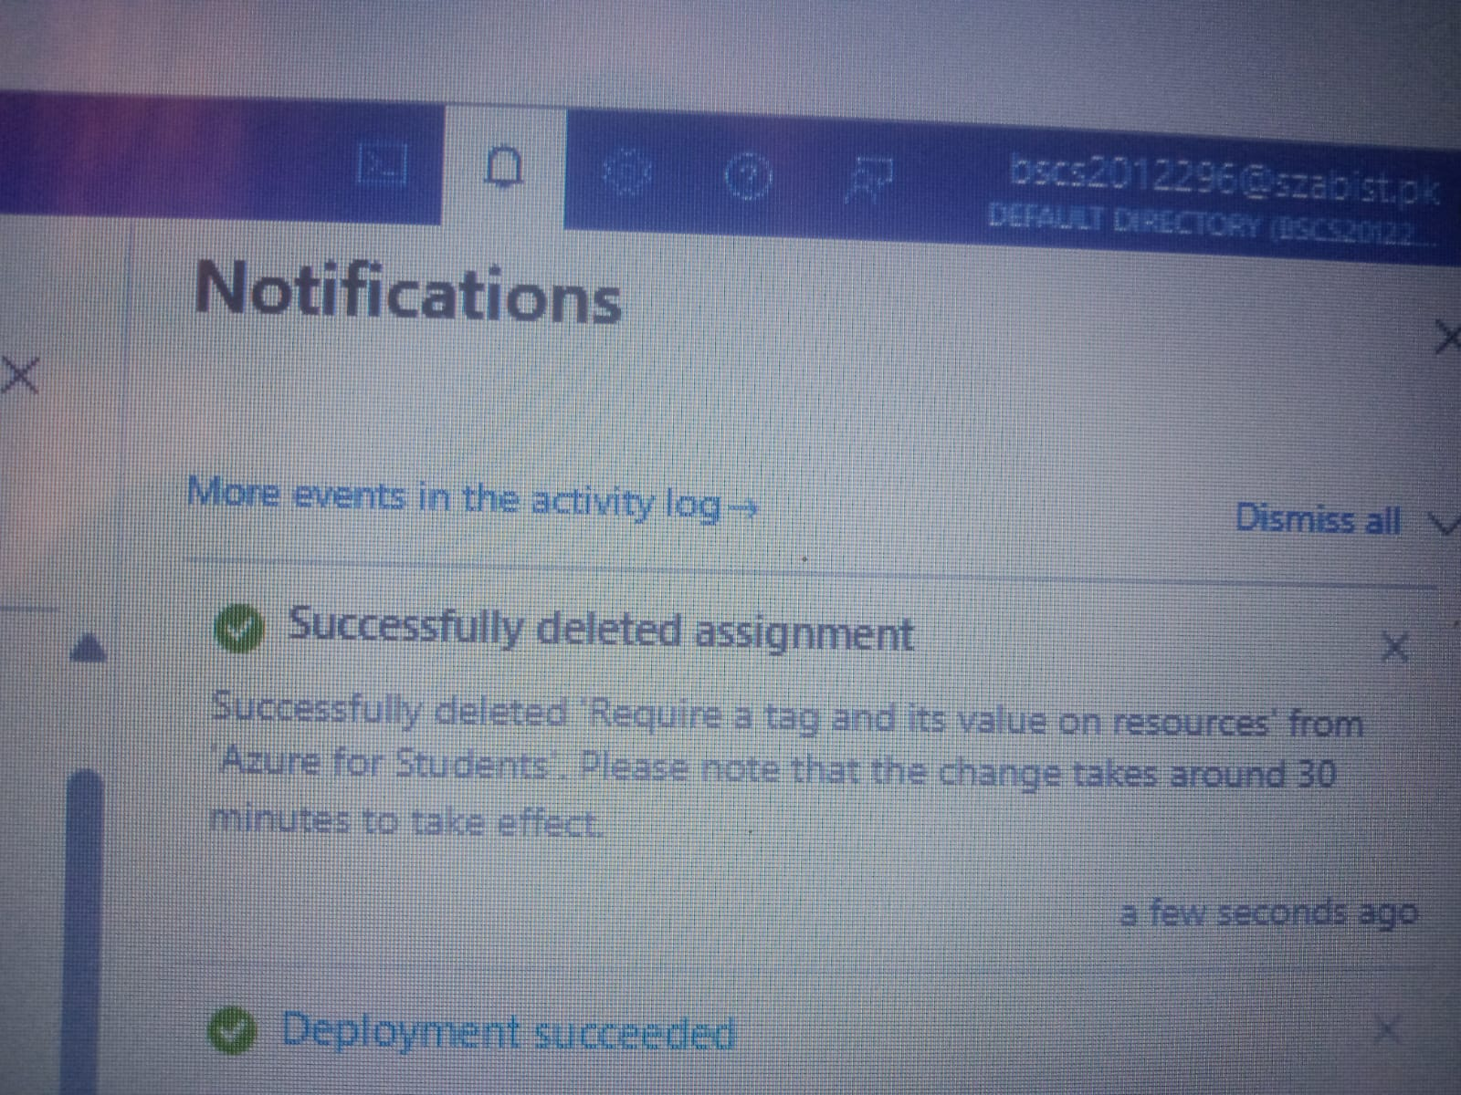

Description:
In this lab, we learn how to apply and enforce resource tagging policies in Microsoft Azure. First, we create a policy that requires all resources to have a specific tag (Company: Contoso). We then test the policy by trying to create a storage account without the required tag, which fails. After adding the correct tag, the resource is successfully created. Finally, we learn how to filter resources by tags and remove the policy when no longer needed.

